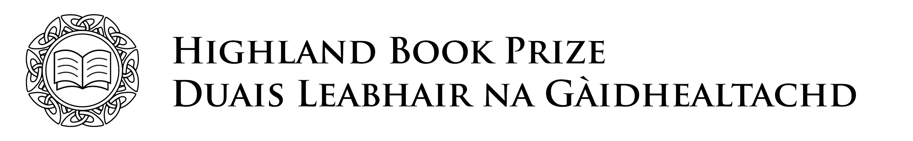
Entry Form 2020

Book title
Author(s) name(s)
Genre and key theme(s)

Short description of the book
Short paragraph about the author

ISBN
Publication date
Publisher name and address

Contact number
Publisher email

Please identify which criteria this title meets (books must meet at least ONE of the following)

- Promotes or concerns itself with Highland culture, heritage or landscape
or
- Has a significant amount of activity set in the Highlands
or
- The author(s) were born/brought up in the Highlands
or
- The author(s) lived in the Highlands for a period of 6 years or more

Please confirm that you have read and agree to the Highland Book Prize rules as stated above.

Signed _____________________________________________ Date____________________

Print name and job title ________________________________________________________

Please email this form, together with a PDF or eBook version of the title to highlandbookprize@moniackmhor.org.uk no later than 5pm on Wednesday 12th August 2020.

