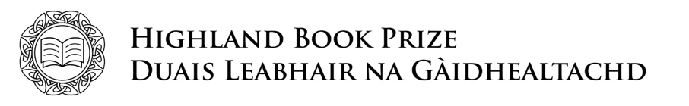

ENTRY FORM 2022

Full title of the entry
Author(s) name(s)
Genre and key theme(s)

Short description of the book
Short paragraph about the author

ISBN
Publication date
Publisher main contact name and address
Contact number
Publisher main contact email

Continued overleaf.

Please identify which criteria this title meets (books must meet at least ONE of the following)

- Promotes or concerns itself with Highland culture, heritage, or landscape

Please give brief details of eligibility:

- Has a significant amount of activity set in the Highlands

Please give brief details of eligibility:

- The author(s) was born/brought up in the Highlands

- The author(s) is a permanent resident in the Highlands

Please confirm that you have read and agree to the Highland Book Prize rules. Please sign below.

Signed:

Date:

Print name and job title:

Please email this form, together with a PDF (or eBook or mobi version) of the title to highlandbookprize@moniackmhor.org.uk no later than 5pm on Friday 19th August 2022.

We would also appreciate if the author(s) could complete our Equalities, Diversity, and Inclusion Monitoring Form.
Click here to download the form from our website.

